**Data Management Page:** [**https://github.com/djgamekid/GDP-Group-I-bearcatmanager/wiki/Data-Management-Plan-(Iteration-1)**](https://github.com/djgamekid/GDP-Group-I-bearcatmanager/wiki/Data-Management-Plan-(Iteration-1)) **Group 1  
 Darren Ross**

**Anthony Jack**

**Manikala Chevitipalli**

**Sai Achyuth Konda** 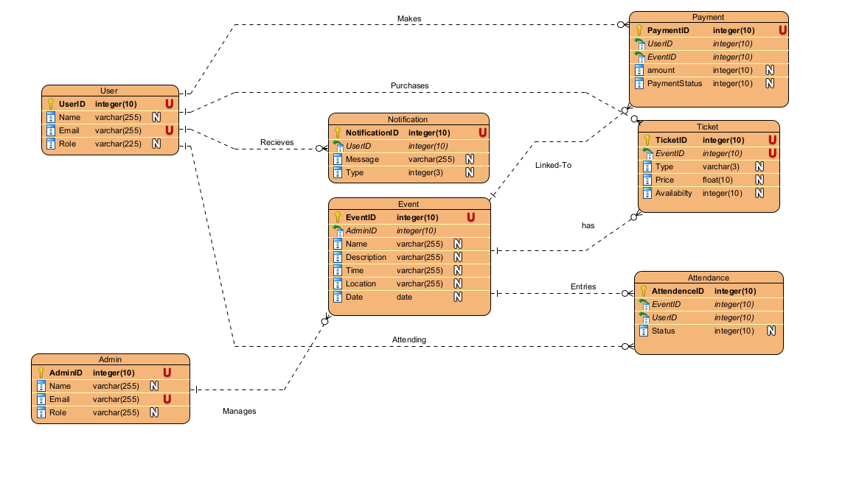

**Summary of Data to be Stored**

**1. Admin Information**

* **Admin ID**: A unique identifier for each admin.
* **Name**: The name of the admin.
* **Email**: The email address of the admin.
* **Role**: The role of the admin within the system.

**2. User Information**

* **User ID**: A unique identifier for each user (student or staff).
* **Name**: The name of the user.
* **Email**: The email address of the user.
* **Role**: The role of the user (either Student or Staff).

**3. Event Details**

* **Event ID**: A unique identifier for each event.
* **Admin ID**: The identifier for the admin managing the event.
* **Name**: The name of the event.
* **Description**: A brief description of what the event is about.
* **Time**: The time the event starts.
* **Location**: Where the event will take place.
* **Date**: The date the event is scheduled for.

**4. Ticket Information**

* **Ticket ID**: A unique identifier for each ticket type.
* **Event ID**: The identifier for the event associated with the ticket.
* **Type**: The type of ticket (e.g., NOM or VIP).
* **Price**: The cost of the ticket.
* **Availability**: The number of tickets available for purchase.

**5. Attendance Records**

* **Attendance ID**: A unique identifier for each attendance record.
* **Event ID**: The identifier for the event for which the user is attending.
* **User ID**: The identifier for the user attending the event.
* **Status**: The status of the user’s attendance (e.g., checked in or not).

**6. Notification Details**

* **Notification ID**: A unique identifier for each notification.
* **User ID**: The identifier for the user receiving the notification.
* **Message**: The content of the notification message.
* **Type**: The type of notification (e.g., Email, SMS, or App notification).

**7. Payment Information**

* **Payment ID**: A unique identifier for each payment transaction.
* **User ID**: The identifier for the user making the payment.
* **Event ID**: The identifier for the event associated with the payment.
* **Amount**: The amount paid.
* **Payment Status**: The status of the payment (e.g., completed, pending, failed).

**Data Security Plans**

**Initial Plans to Secure Data**

1. **Access Restrictions**:
   * **User Roles**: Implement role-based access control (RBAC) to ensure that users only have access to data necessary for their role (e.g., Admin, User, Event Organizer).
     + **Admins** will have full access to manage events, users, and notifications.
     + **Users (Students/Staff)** will have restricted access, allowing them to view and register for events, purchase tickets, and receive notifications.
   * **Authentication**: Require strong authentication methods (e.g., password policies, two-factor authentication) to access the system and sensitive data.
2. **Data Encryption**:
   * **At Rest**: Use encryption to secure sensitive data stored in the database, such as user emails, payment information, and notifications. AES (Advanced Encryption Standard) is recommended for this purpose.
   * **In Transit**: Implement HTTPS to encrypt data transmitted between users and the server, preventing interception during data exchange.
   * **Sensitive Fields**: Specifically encrypt sensitive fields like Email, Payment Amount, and Notification Message to further enhance security.
3. **Regular Security Audits**:
   * Conduct regular security audits and vulnerability assessments to identify and mitigate potential risks in the system.
4. **Data Backup and Recovery**:
   * Implement a data backup strategy to ensure that all data is regularly backed up and can be restored in the event of data loss or a security breach.

**Mapping of Functional Requirements to Data Storage**

1. **User Registration and Management**:
   * **Related Data Storage**: User table
   * **Requirements**: Store user information securely and allow admins to manage user accounts.
2. **Event Management**:
   * **Related Data Storage**: Event table, Admin table
   * **Requirements**: Admins need to create, update, and delete events, associating them with their profiles.
3. **Ticket Sales**:
   * **Related Data Storage**: Ticket table, Payment table
   * **Requirements**: Users should be able to purchase tickets, and relevant payment data should be securely stored and processed.
4. **Attendance Tracking**:
   * **Related Data Storage**: Attendance table
   * **Requirements**: Track user attendance at events, enabling event organizers to manage participants effectively.
5. **Notifications**:
   * **Related Data Storage**: Notification table
   * **Requirements**: Notify users about events, updates, and reminders securely without exposing sensitive information.
6. **Payment Processing**:
   * **Related Data Storage**: Payment table
   * **Requirements**: Securely store transaction details, including user IDs and event IDs, to track payments made by users.